CREATE table employee(EMPID INT,EMPNAME VARCHAR(20),DEPTID INT,SALARY INT,HIREDATE DATE,DEPTID INT,DEPTNAME VARCHAR(20));

DESC EMPLOYEE;

INSERT INTO employee (EMPID, EMPNAME, DEPTID, SALARY, HIREDATE,DEPTID,DEPTNAME)

VALUES

(101, 'Ramya', 1, 20000, '2018-02-12',1,'IT'),

(102, 'John', 2, 30000, '2017-07-10',2,'CSE'),

(103, 'Alice', 3, 40000, '2023-03-11',3,'IT'),

(104, 'Carol', 4, 50000, '2020-10-12',4,'CSE');

SELECT * FROM employee;

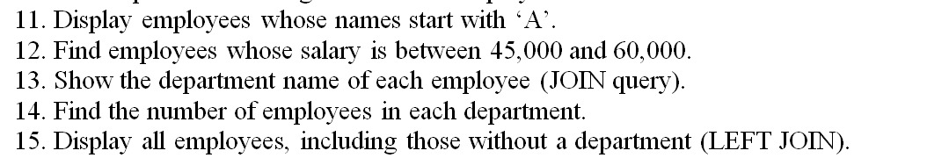

**11.Display employees whose name start with ‘A’.**

SELECT EMPNAME FROM employee WHERE EMPNAME LIKE 'A%'**;**

**12.Find employees whose salary is between 45,000and60,000.**

SELECT SALARY FROM employee WHERE SALARY BETWEEN 45000 AND 60000;

**13.Show the department name of each employee(join query).**

CREATE TABLE department (

DEPTID INT,

DEPTNAME VARCHAR(20)

);

CREATE TABLE employee (

EMPID INT,

EMPNAME VARCHAR(20),

DEPTID INT,

SALARY INT,

HIREDATE DATE

);

INSERT INTO department (DEPTID, DEPTNAME)

VALUES

(1, 'IT'),

(2, 'CSE'),

(3, 'IT'),

(4, 'CSE');

INSERT INTO employee (EMPID, EMPNAME, DEPTID, SALARY, HIREDATE)

VALUES

(101, 'Ramya', 1, 20000, '2018-02-12'),

(102, 'John', 2, 30000, '2017-07-10'),

(103, 'Alice', 3, 40000, '2023-03-11'),

(104, 'Carol', 4, 50000, '2020-10-12');

SELECT e.EMPNAME, e.SALARY, d.DEPTNAME

FROM employee e

JOIN department d ON e.DEPTID = d.DEPTID;

**14.Find the no of employee in each department.**

SELECT d.DEPTNAME, COUNT(*) AS NumOfEmployees

FROM employee e

JOIN department d ON e.DEPTID = d.DEPTID

GROUP BY d.DEPTNAME;

**15.Display all employee including those without a department(left join)**

SELECT e.EMPNAME, e.SALARY, d.DEPTNAME

FROM employee e

LEFT JOIN department d ON e.DEPTID = d.DEPTID;